PROBLEM STATEMENT AND SOLUTIONS:

### **1: Problem Statement**

The objective was to analyse the **year-on-year (YoY) debt exposure trends** of neighbouring countries and evaluate both **individual country-level changes** as well as the **overall debt dynamics**.

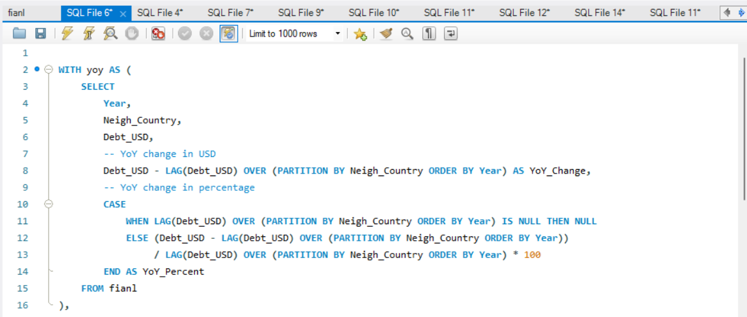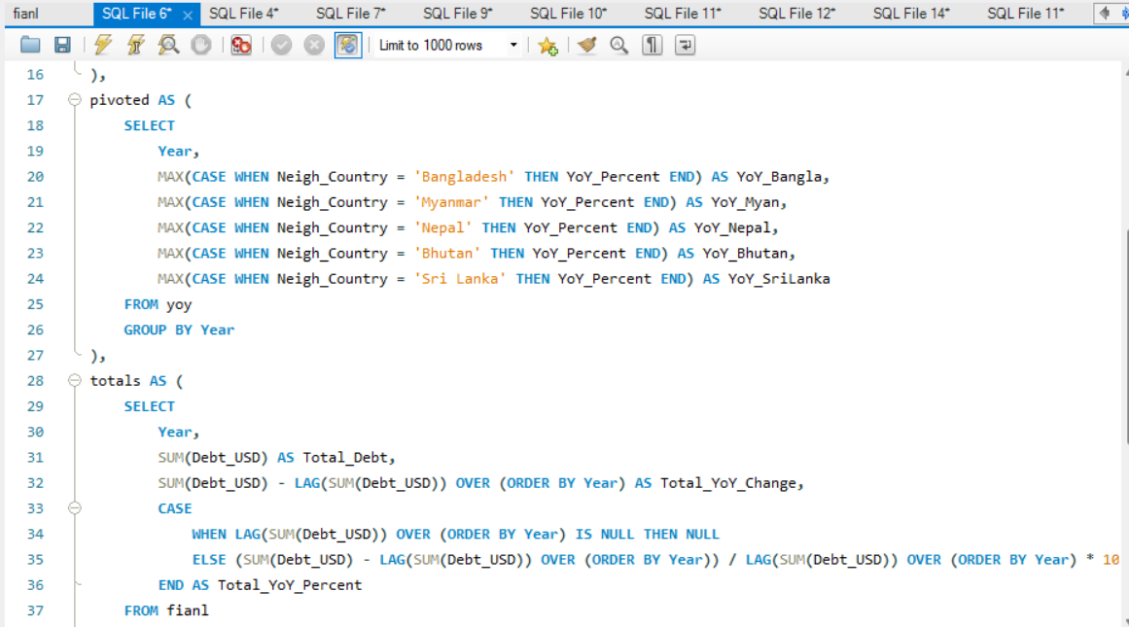

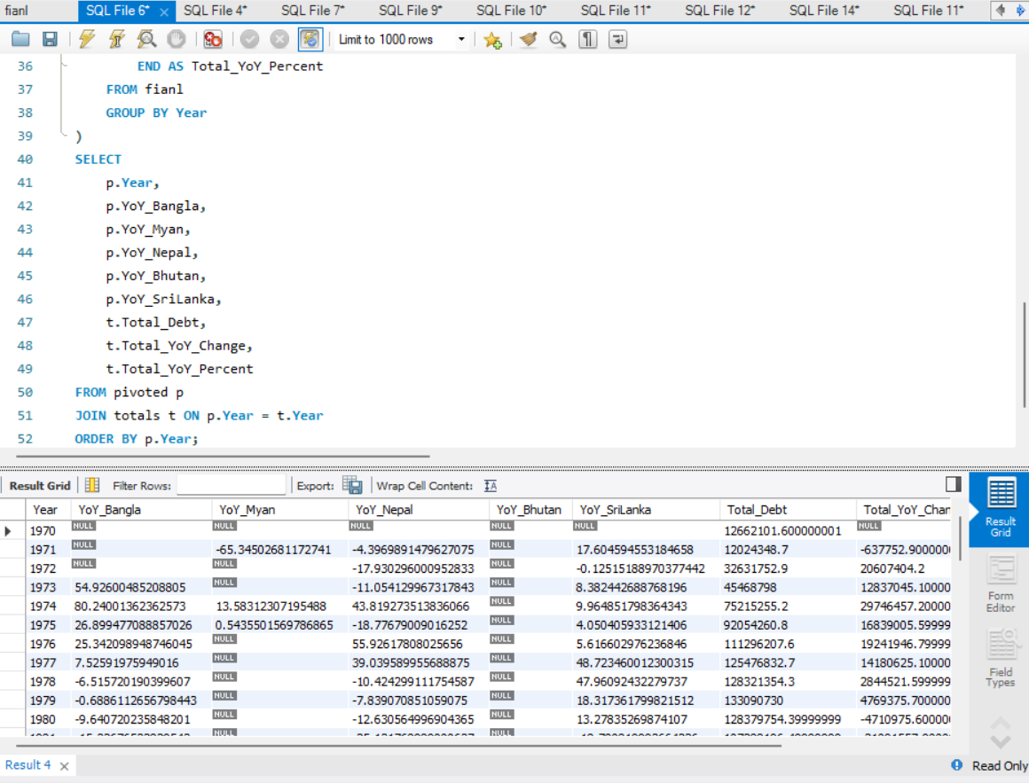

**Solution / Insight Provided**

* Calculated **YoY change in debt** (absolute and percentage) for each country.
* Pivoted the dataset to **compare multiple countries side by side** for each year.
* Computed **total debt portfolio YoY growth** across all countries combined.
* The output enables identification of **debt growth leaders** and helps track **regional financial exposure trends** over time.

### **2: Problem Statement:**

The goal was to analyse the debt distribution among neighbouring countries in any given year. Specifically, the requirement was to calculate each country’s percentage share of the total debt for that year in order to understand relative exposure and dominance.

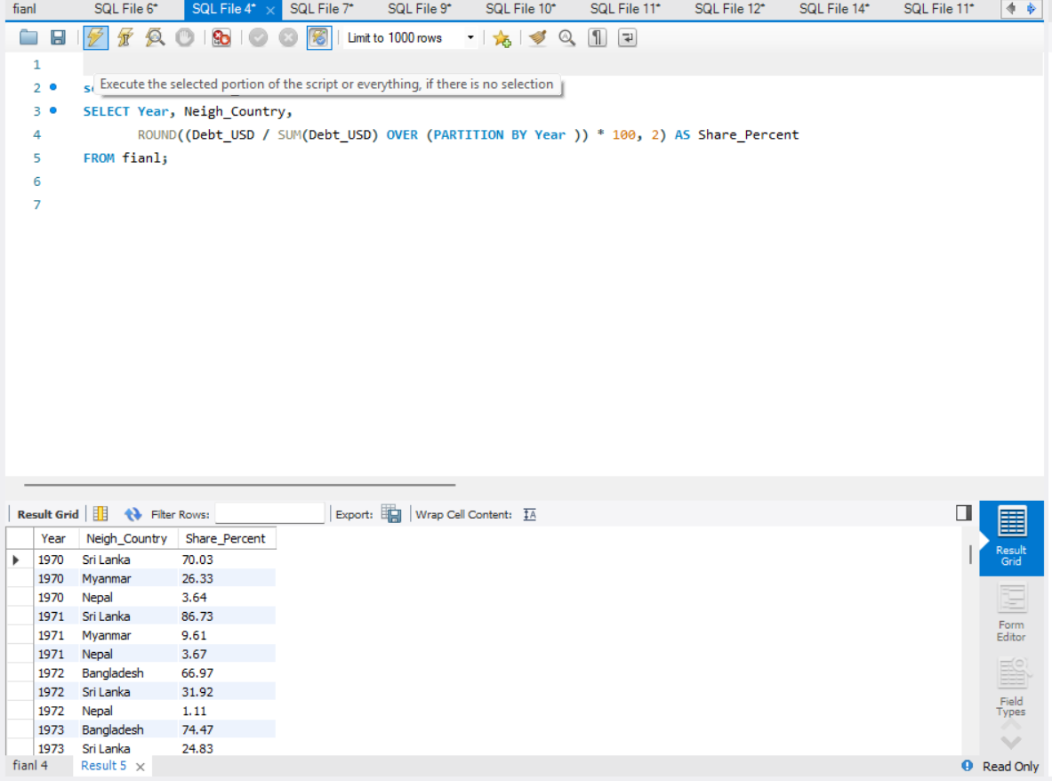

**Solution / Insight Provided**

* Computed the **percentage contribution** of each neighboring country’s debt to the **total debt in a given year**.
* Helped to validate whether the **share distribution adds up to 100%** for every year.
* Useful for identifying which country holds the **largest exposure share** and how that dominance shifts across different years.

### **3: Problem Statement**

The requirement was to identify **which neighbouring country had the highest debt exposure in each year**. This helps analyse the **shift in dominance of debt holding** over time.

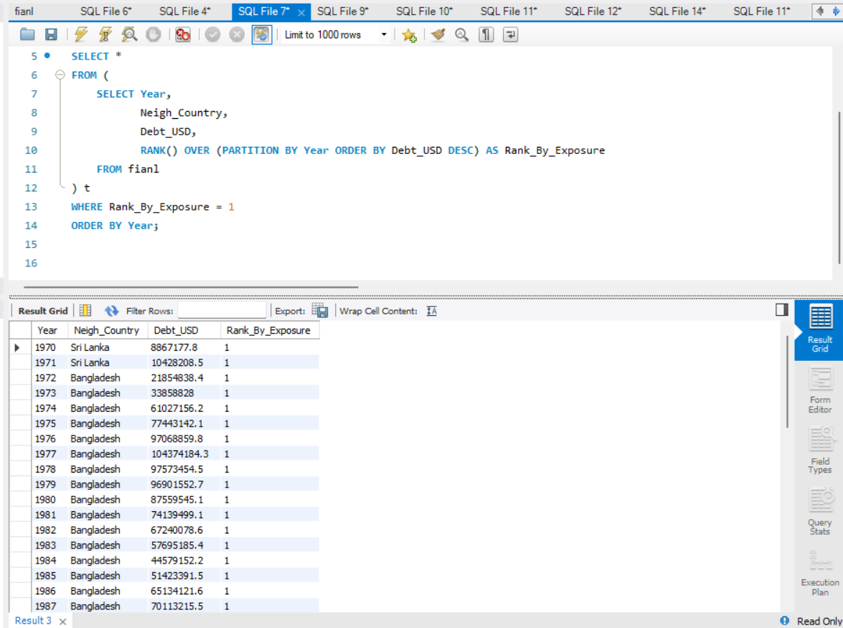

**Solution / Insight Provided**

* The query applies a **ranking function** within each year to order countries by debt exposure.
* By filtering only those with **Rank = 1**, it extracts the **top country per year**.
* This provides a clear view of **year-wise leaders in debt exposure**, making it easier to track if a new country overtook the previously dominant one.
* Supports **trend analysis** of how debt exposure is concentrated or shifting among neighbouring countries.

### **4: Problem Statement**

The goal was to analyse **long-term debt growth trends** by:

1. Dividing years into **5-year periods**.
2. Measuring **growth within each period** for every neighbouring
3. Calculating **average growth across all periods**.
4. Identifying the **top countries with the highest average 5-year growth**

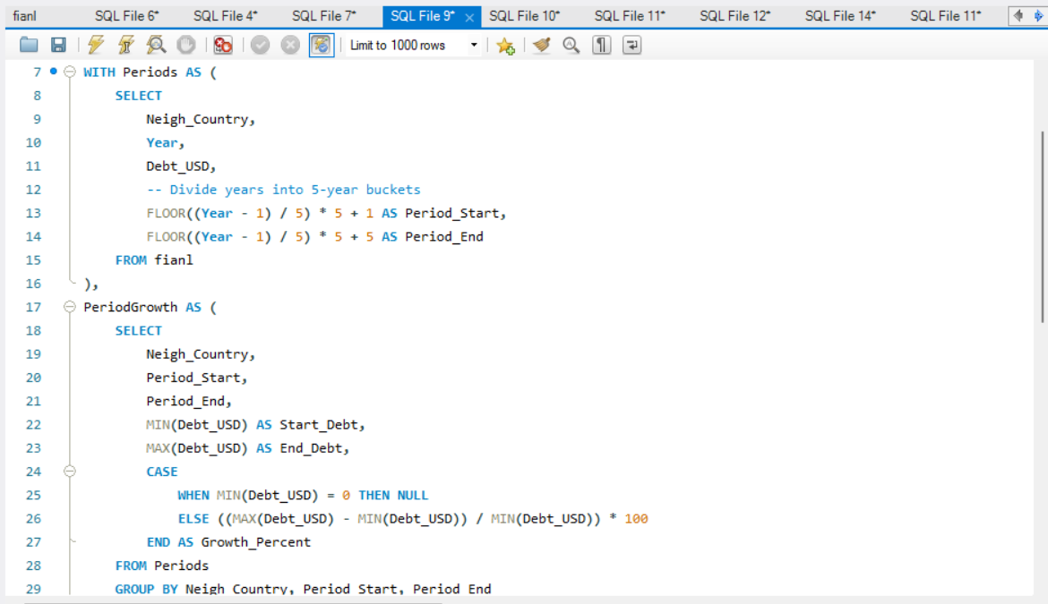

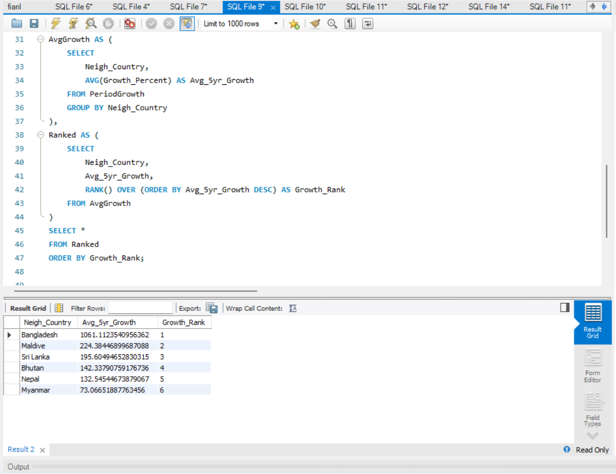

**Solution / Insight Provided**

* The query first **groups years into 5-year buckets** (Periods CTE).
* It then calculates **growth percentage within each 5-year period** for each country (Period Growth).
* The **average growth rate across all 5-year windows** is computed (AvgGrowth).
* Finally, countries are **ranked by their long-term average growth** (Ranked

### **5: Problem Statement**

We want to measure **how much influence each neighboring country holds** in terms of debt share over the years.  
Since yearly values may fluctuate sharply, we also want to calculate a **smoothed rolling average influence score** to observe long-term dominance patterns.

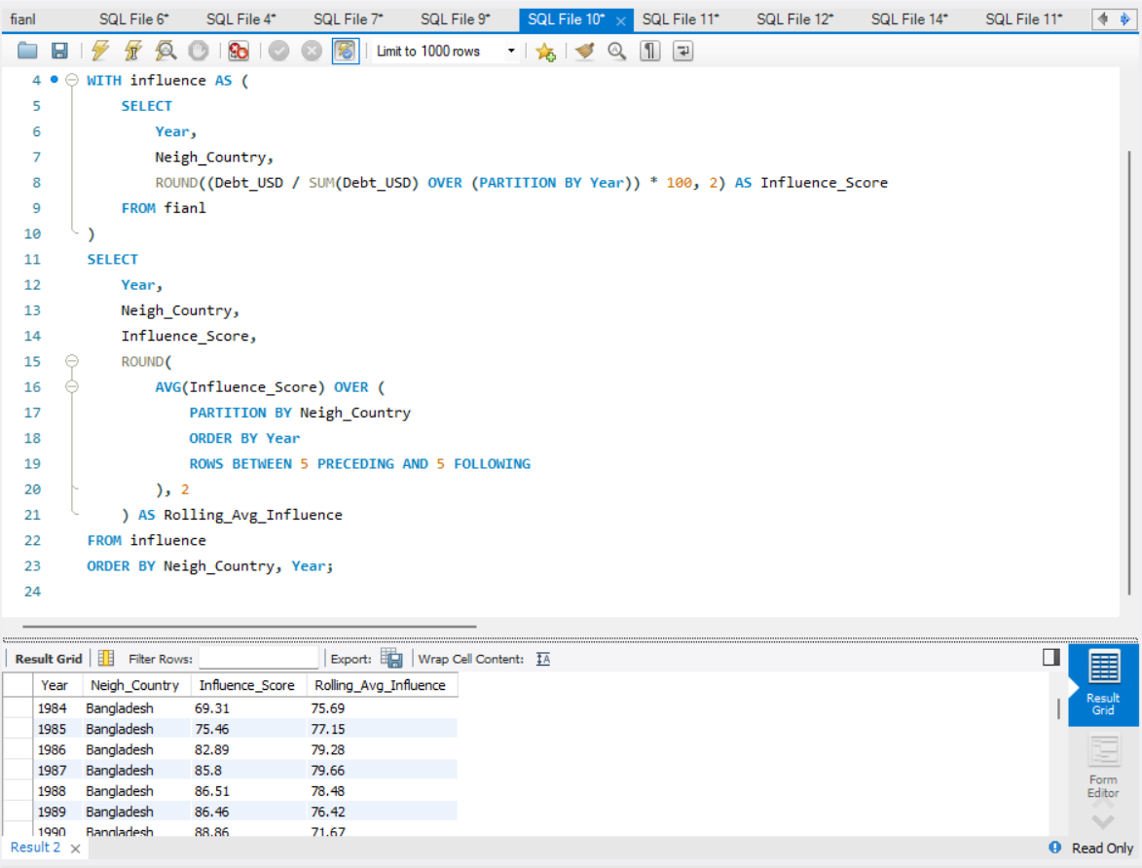

**Solution / Insight Provided**

* The query first **groups years into 5-year buckets** (Periods CTE).
* It then calculates **growth percentage within each 5-year period** for each country (Period Growth).
* The **average growth rate across all 5-year windows** is computed (Avggrowth).
* Finally, countries are **ranked by their long-term average growth** (Ranked).

### **6: Problem Statement**

The problem is to summarize total debt for each neighbouring country annually in a structured manner for analysis and visualization.

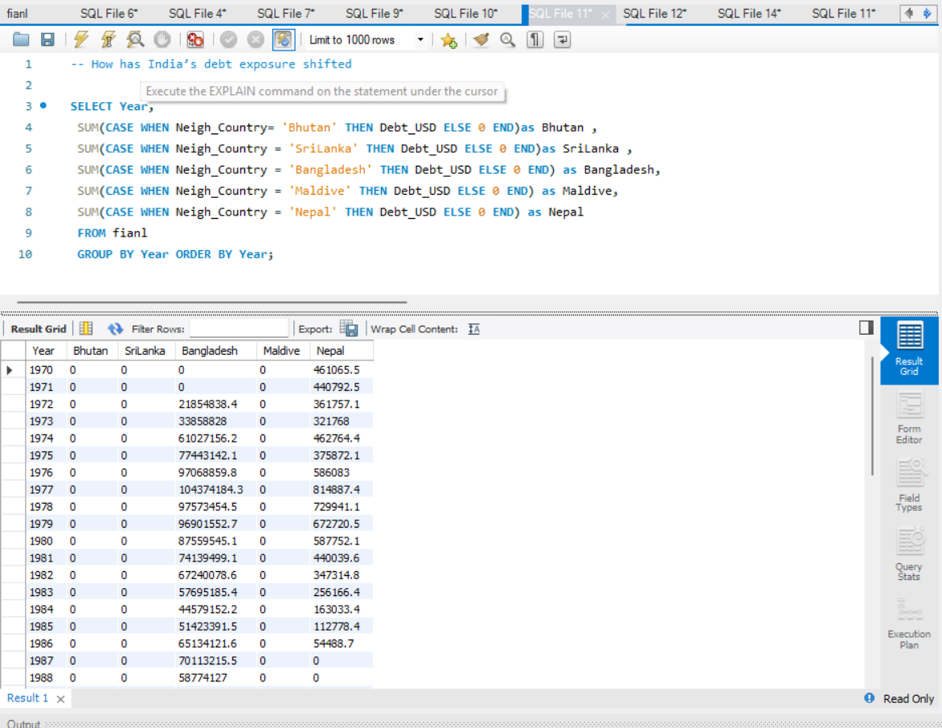

**Solution / Insight Provided:**  
This SQL query solves the problem by:

1. **Aggregating debt values** per neighbouring country for each year using SUM and CASE statements.
2. **Pivoting the data** so that each neighbouring country has its own column, making it easier to compare debts year by year.
3. **Ordering by Year** to analyse trends over time

### **7: Problem Statement**

The problem is to identify the top two countries with the highest debt each year and quantify their contribution in absolute and percentage terms.

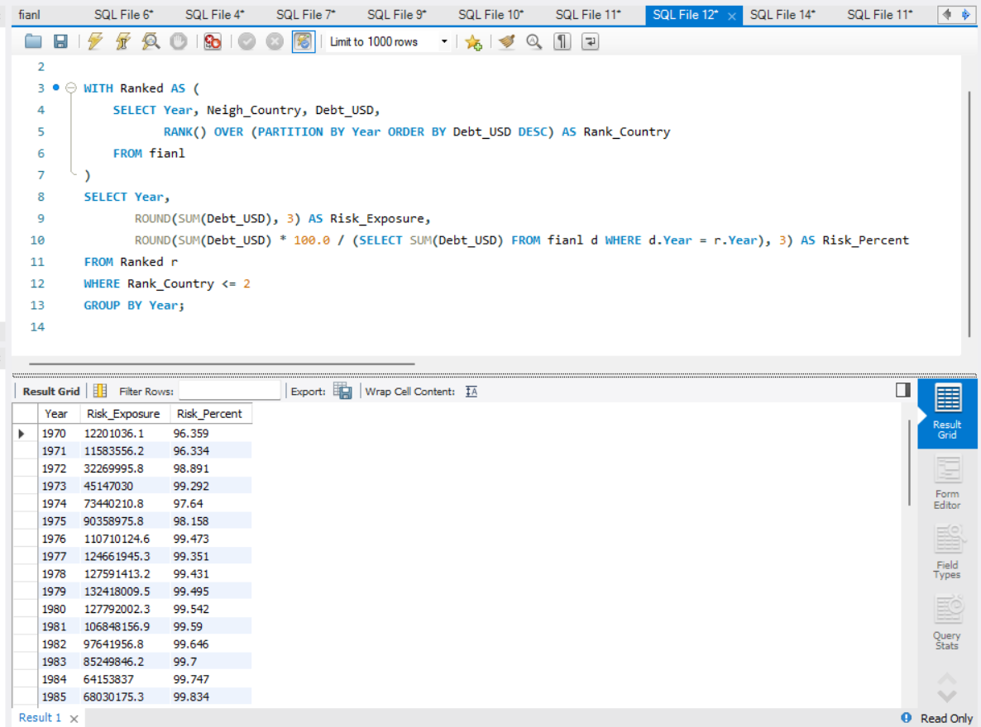

**Solution / Insight Provided:**

1. **Ranking Countries by Debt**
   * Using a **CTE (Ranked)**, each country is ranked **within each year** by debt amount.
   * This highlights the **highest-risk countries**.
2. **Selecting Top 2 Countries**
   * Rank_Country <= 2 filters the top 2 debt contributors per year.
3. **Calculating Risk Exposure**
   * Risk_Exposure gives the **total debt from the top 2 countries**.
   * Risk_Percent calculates their **share of total debt**, indicating concentration risk.

### **8: Problem Statement**

The problem is to **measure the variability in debt exposure for each neighboring country** to identify which countries have the most unpredictable debt patterns.

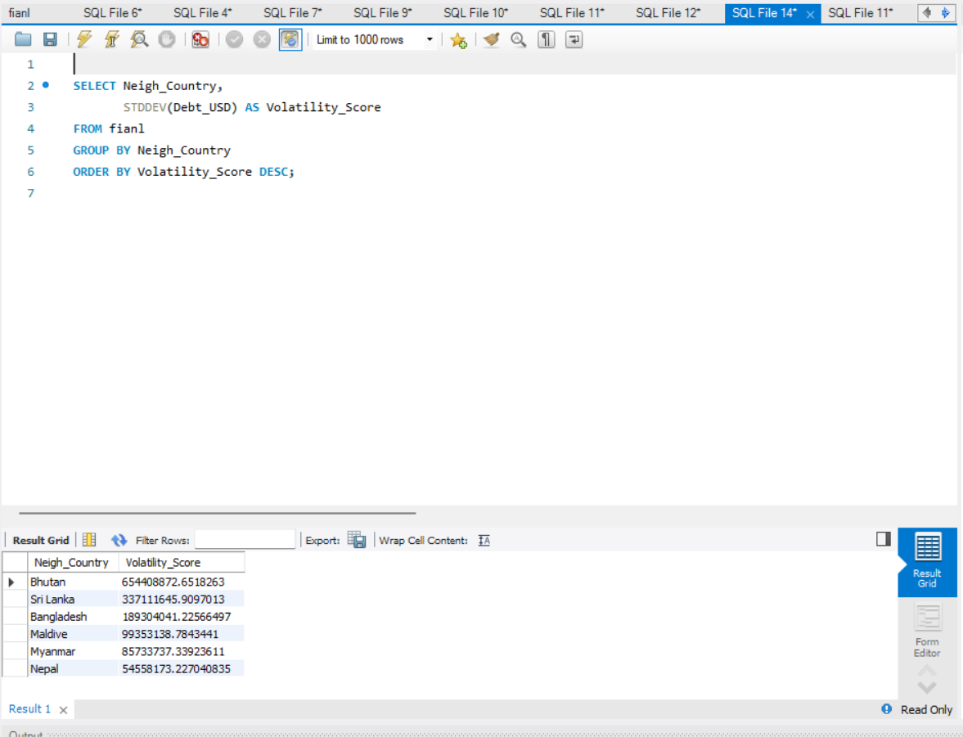

**Solution / Insight Provided:**

**Measuring Volatility**

* The query calculates the **standard deviation (STDDEV)** of debt for each neighbouring country.
* Grouping by Neigh_Country ensures the score is calculated **per country**.

**Insights:**

* Countries with high Volatility_Score are more financially unpredictable, indicating potential risk.
* Countries with low scores are stable, suggesting safer debt exposure.
* Helps analysts monitor and mitigate risk, focusing on countries with high debt fluctuations.

### **9: Problem Statement**

The problem is to calculate the Compound Annual Growth Rate (CAGR) of debt for each neighbouring country, providing a standardized measure of growth over the observed period.

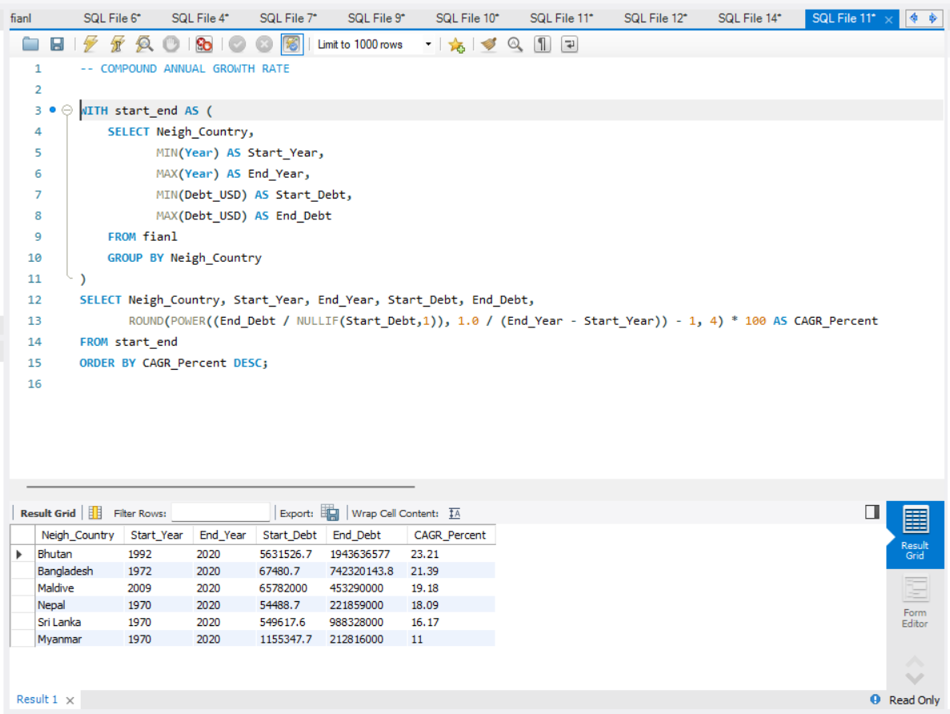

**Solution / Insight Provided:**

1. **Identify Start and End Values**
   * Using a CTE (start_end), the query identifies the **first and last year** of observation for each country and their respective debt values (Start_Debt and End_Debt).
2. **Order by CAGR**
   * Countries are ordered by CAGR_Percent descending to **highlight the fastest-growing debt relationships**.

**Insights:**

* Reveals which neighbouring countries’ debt is growing most rapidly over the period.
* Helps in **strategic debt planning and forecasting**.
* Supports identifying countries that may require **closer monitoring or mitigation strategies**.